|  |  |  |  |  |  |  |
| --- | --- | --- | --- | --- | --- | --- |
| **N  -------------Değer Sayısı** | 1 | 2 | 3 | 4 | 5 |  |
|  |
| 100 | 0.001407 | 0.001520 | 0.004118 | 0.004449 | 0.004717 |  |
| 1000 | 0.007827 | 0.012528 | 0.022334 | 0.025794 | 0.032842 |  |
| 10K | 0.144218 | 0.317573 | 0.452676 | 0.642773 | 0.705386 |  |

**Çalışma süreleri:**

**100**

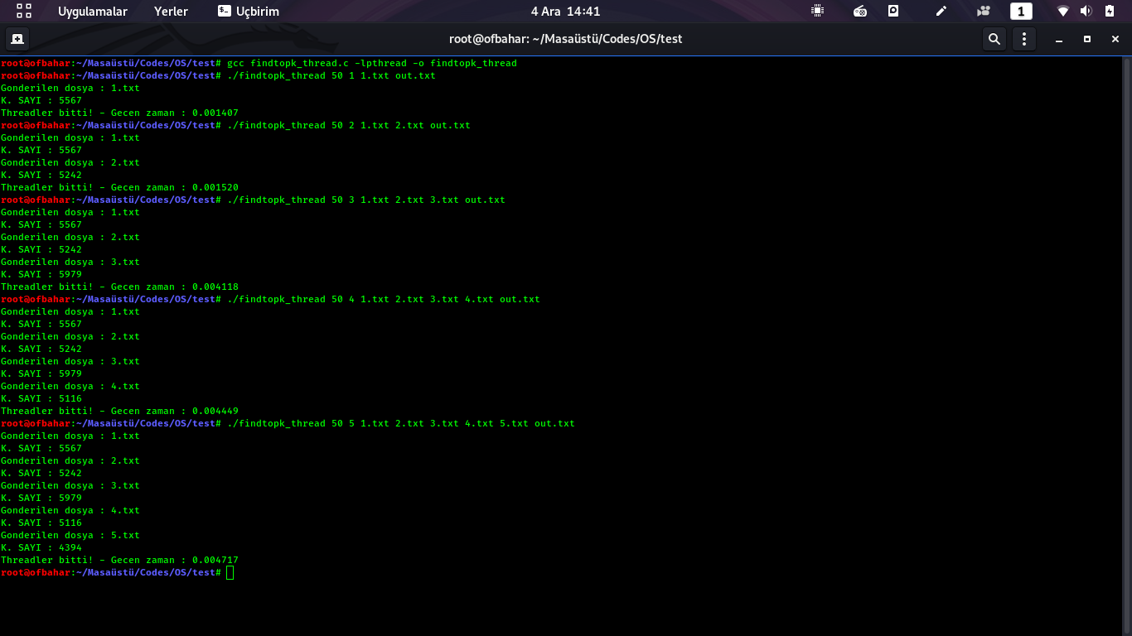

**1000**

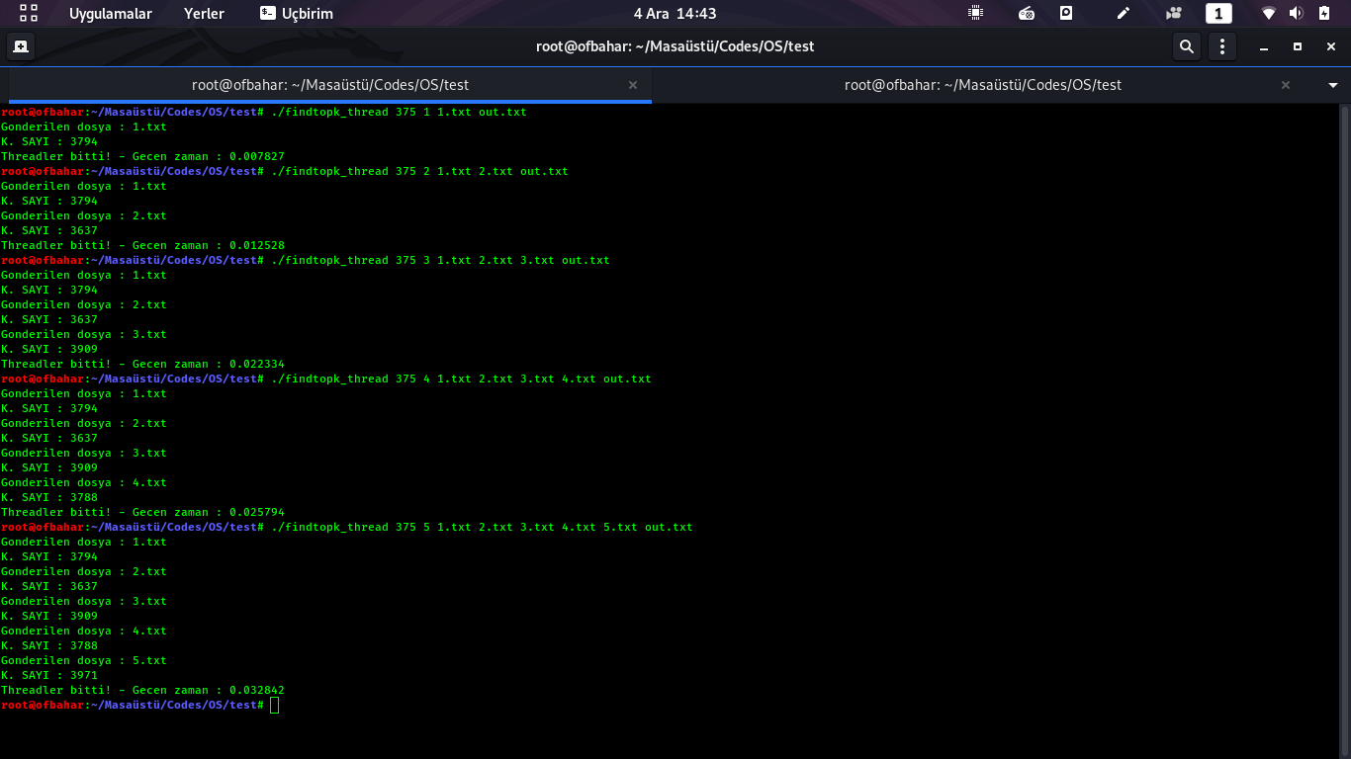

**10K**

